Good morning
Na dzisiejszej lekcji zajmiemy się powtórzeniem słownictwa, które poznaliście w unicie 8.
Przed Wami 3 zadania do wykonania. GOOD LUCK
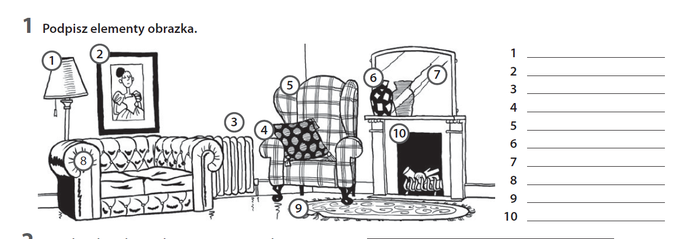
2.Dopasuj pojęcia do objaśnień.

1 We put this on the floor.
2 We look at ourselves with this.
3 This helps keep a room warm.
4 We put our things in this.
5 This is a picture that goes on the wall.
a radiator
b mirror
c carpet
d painting
e cupboard

3. Zakreśl właściwą opcję.
1 Dad’s always sits in his favourite armchair / vase when he watches TV.
2 Our lamp / coffee table broke because we put too many things on it.
3 Grandma loves sitting next to the sofa / fireplace to keep warm.
4 Mum has lots of small plants on the carpet / windowsill so they can have a lot of light.
5 I have a small cushion / rug on the floor in my room.

